Chapter 3, Solution 77

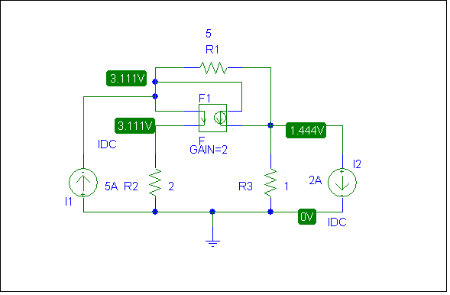

As a check we can write the nodal equations,

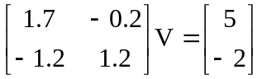

Solving this leads to V₁ = 3.111 V and V₂ = 1.4444 V. The answer checks!

